Mastermind—A Board of Directors For Your Success

By Kurt DuNard, The Exceptional Life Coach

How can you get the smartest, most talented, well connected people to work for your success FREE of charge? What does it take to get people to be inspired for YOUR benefit? How can we create a system with a free board of directors that is smarter than anything we could do alone? A mastermind group is the answer and is the success tool that propels most high achievers. For some peculiar reason most do not talk about their mastermind groups. As a result, few know about this success tool.

Thomas Alva Edison, Henry Ford, and Harvey Samuel Firestone are three American industrialists, three American heroes that were known for being rugged individualists. None could claim to be highly educated, but all were geniuses in their own areas. In other areas they were ignorant. The truth is they were not as much individualists as most think. They depended on each other to form a mastermind group to think through their company problems. We think Edison, Ford and Firestone were smart individually and they were, but they were much smarter as a group. The three families used to meet in Florida and Thomas, Henry and Harvey would take the boat out to fish. What is strange, is that during all the years of fishing, they never brought anything home for dinner. They actually were
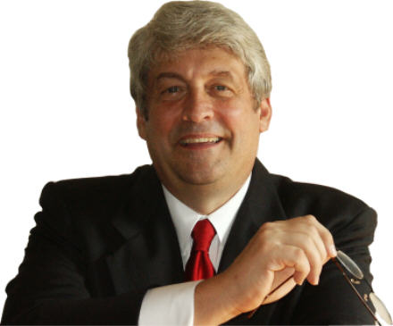

conducting mastermind meetings out in the ocean where they could not be interrupted. Is it any wonder that three giant minds, such as these, could combine for such monumental success to totally change America and the world? I am convinced that without the mastermind group they could not have had nearly as great a success. You can also tap into this same success accelerator. That is, you can tap into it if you are willing to help make others become successful and are willing to let others help you become successful.

Creating a Mastermind Group

The most important aspect of a mastermind group is the quality of its members. These should be people who are not competitive with one another and who genuinely want to see each other succeed. They can be from the same industry but sometimes it is better if they are from another industry. They must give as much as they take or the group is bound to fail. Like the old story of Heaven and Hell where everyone sits at a banquet table with three food long forks. Hell is where the individualist tries to feed himself with the three foot long fork and fails. Heaven is where the people feed each other and succeed. The mastermind group is where we feed each other till all of us succeed. Here is how it is done.

1. Have 2-8 Members: Keep the group small so everyone can contribute in the allotted time.

2. Meet Frequently for 1-1 ½ Hours: The more frequent the meetings, the more powerful the mastermind group and the greater the results. Try to meet weekly.

3. This is no place for spectators. Make sure everyone participates at their highest involvement. This means bringing great ideas to the meetings, sharing any information that will help, supporting others in their struggles, giving advice, telling about contacts and resources, and using creativity in general to advance the group. Feed others and they will feed you.

4. Keep the Meetings Positive and Upbeat. Start the meeting with an affirmation of positive outcome, valuable insight, and incredible success. Each member should tell about something positive that happened since the last meeting. Talk about anything that will start the spiral up to positive thinking.

5. Member Reports: Each member is allotted a specific amount of time to talk about a new discovery or opportunity that will help the group. During this time, that member can also talk about a challenge in his or her business in which he or she would like help or advice. They can start a discussion with their remaining time. Let everyone have equal time or the group will fail because some members are not served.

6. End on a Positive Note: Give thanks to one another for specific help and advice. Acknowledge specific contributions so that everyone will want to continue to contribute advice, and support. This is a “feel good” time so that people will look forward to the next meeting. By ending in this way, the group is strengthened.

When you have friends cheering you on for your success, you will find that you gain strength, discipline and accountability. Your mastermind group will make it easier to be successful.

Who are three people you could call today to start your group?

Copyright © 2008 Kurt DuNard

WOULD YOU LIKE TO USE THIS ARTICLE IN YOUR NEWSLETTER, BLOG OR WEB SITE?
You have permission if you include the following complete statement upon use:

Kurt DuNard, The Exceptional Life Coach, is the author of EXCEPTIONAL LIFE: Living the Life You Were Meant to Live. High achievers seek him out to pinpoint their soul’s goals, increase abundance, and find more happiness and joy. If you think you would also like these things, then receive your FREE success tools from Kurt DuNard now at www.iihp.com.

and send a copy of the article to:

Kurt DuNard
Suite #172
3510 NE 3rd Ave.
Camas, WA 98607

Weekly Quote

When we unselfishly help each other, we unselfishly help ourselves.

--Kurt DuNard


Order the book—
Exceptional Life—Living the Life You Were Meant To Live.

Click on:

www.CranePress.com

