Self-Talk

Change Your Talk and You Change Your Luck

By Kurt DuNard, The Exceptional Life Coach.

Do you remember the childhood expression: “Sticks and stones may break my bones but words will never hurt me?” As children, we were taught a lot of miss information but one thing we were taught that is powerfully true is that words can be magic and can change circumstances. They can also break bones. Like Harry Potter and the apprentice wizard, we must be very careful how we use our words, especially when we are talking or thinking about ourselves. One or two misspoken phrases and we could end up where we don’t belong, on top of a mountain or in the bottom of a dungeon.

Success experts agree that what we think about the most tends to eventually show up in our lives. Words are the building blocks of thoughts and when those words, those thoughts, especially spoken words are about us, then we know a little about our future. The best strategy is to eliminate the negative words and thoughts and give powerful emotions to positive words and expectations. If you don’t expect much, you won’t get much. Have great expectations.

Make Your Self-Talk Positive
Would you believe that you have about 50,000 thoughts a day? Now, ask yourself whether most of them are positive or negative? Are some of the thoughts negative like:

I can’t handle this.
I am the low man on the totem pole.
I am too fat.
I can’t learn a foreign language.
I am too old.
I am too young.
I don’t have enough education.
I have too much education.
I don’t know the right people.
Etc., etc., etc.

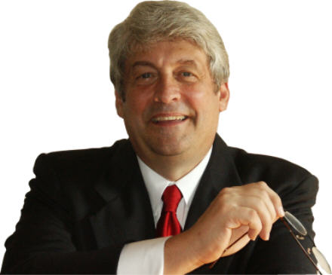

Many psychologists call the above statements victim language. The victim is stating all the reasons why it’s not his or her fault that they can’t have success. Victim language is negative and will keep the person a victim just as surely as if Harry Potter waved his magic wand and turned her into a frog.

No matter how hard it is and no matter how illogical the thoughts and words, one MUST turn the victim language into winner language.

I have a great feeling about this.
I am always lucky.
Somehow, everything tends to work out.
If I just start, I know it will get easier.
I find an answer to every problem.
Help seems to come when I need it.
Our Subconscious Brings Success or Failure
Remember the old WWII submarine movie where the captain is looking through the periscope and all of a sudden he sees a destroyer coming right at him? The captain yells “DIVE! DIVE!” The next officer yells “DIVE! DIVE!” and you hear the order repeated all the way through the submarine. You are the captain and the crew is your subconscious. Your subconscious follows orders exactly, even if they are a joke. It does not have a sense of humor. If you say: “If I didn’t have bad luck, I would not have any luck at all,” then you can bet that you will play the wrong cards at poker—your subconscious will see to it.

Have you ever been so preoccupied with a solution at work that you find yourself parking the car at the office and you don’t remember driving there? The subconscious is what pays attention and somehow gets you to work when you are thinking all kinds of other thoughts. The subconscious played the wrong cards in the above example and drove us to work without our attention. Wouldn’t it be wonderful to put it purposely to work for our benefit?

Pay attention to your thoughts and verbal communications and replace negative with positive. If you are working with others such as a coach or mentor, ask him or her to give you a signal when you are voicing negative victim language.

Affirmations to Re-Program the Subconscious
We were given affirmations by our parents, teachers and society as a whole and some of those affirmations were not good for our subconscious. As a child, we are vulnerable to what authority figures tell us about ourselves. Sometimes the Wizard of OZ is only a little man behind a curtain. Many smart people think they are unintelligent because of early bad affirmations. We can deprogram this malware, these negative victim thoughts, through positive affirmations.

The most powerful affirmations begin with “I am.” What you think about yourself is what the subconscious is going to make into a reality. Here are a few affirmation examples. Have fun making your own affirmations (for a much more extensive discussion about the subconscious, see the book EXCEPTIONAL LIFE: Living the Life You Were Meant to Live by Kurt DuNard)

I am abundance, wealth, and prosperity.
I am perfect health.
I am loved and a lover.
I am happy.
I do important, meaningful work.
I live a completely balanced life.
I have perfect insight and intuition.
I am tapped into Infinite Intelligence.

Now, write, speak and think about your chosen affirmations. You will notice that you start having more positive success thoughts than negative victim thoughts. As the scales weigh more in your favor so will your circumstances.

Live by Purpose Instead of Habit
We can choose to live with the negative victim thoughts that we have habituated with through the years, or we can substitute those thoughts on purpose with positive success thoughts. You must decide. It is as simple as that. Research has found that we can’t think two thoughts at once. If we are thinking positively, then it is impossible to think negatively at the same time. It is really very easy, the more time in the day that we think positively, then the less time in the day that we can think negatively. More positive time means a more positive life.

It is being proven every day that positive self-talk, visualizations, affirmations, prayers, coaching, mentoring, listening to CD’s and audio tapes, and any other methods to influence the subconscious, are changing people’s lives to create exceptional lives. You can too.

Just choose to live an exceptional life, and choose to have exceptional thinking. You can have anything you want, do anything you want to do, and live any life you want to live; that is, if you choose to and give yourself permission. Go for an exceptional life and work with your subconscious.

Copyright © 2008 Kurt DuNard

WOULD YOU LIKE TO USE THIS ARTICLE IN YOUR NEWSLETTER, BLOG OR WEB SITE?
You have permission if you include the following complete statement:

Kurt DuNard, The Exceptional Life Coach, is the author of EXCEPTIONAL LIFE: Living the Life You Were Meant to Live. High achievers seek him out to pinpoint their soul’s goals, increase abundance, and find more happiness and joy. If you think you would also like these things, then receive your FREE success tools from Kurt DuNard now at www.iihp.com.

and send a copy of the article to:

Kurt DuNard
Suite #172
3510 NE 3rd Ave.
Camas, WA 98607
Weekly Quote

Whatever the mind of man can conceive, it can achieve.
--W. Clement Stone

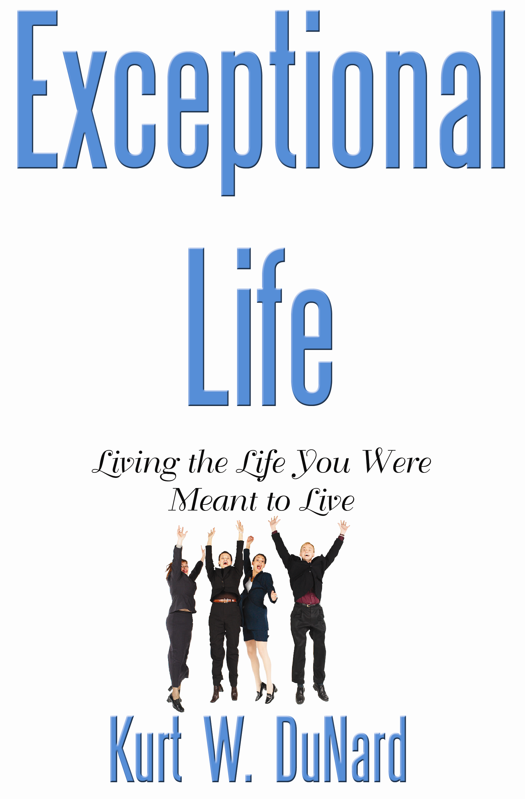
Order the book—
Exceptional Life—Living the Life You Were Meant To Live.

Click on:

www.CranePress.com

